**How many acres of potatoes does a society need? Using food and historical claims in an energy context.**

Nathan T Moore, Physics and General Engineering, Winona State University, Winona, MN USA

December 2023

Supporting calculations and references online at <https://github.com/ntmoore/food_energy_paper/>

**Introduction**

When the United States entered World War One, one of the problems they faced was logistics. How much food do you need to ship across the Atlantic to feed a million soldiers? That early work in nutrition led to the 3000 Calorie diet many people remember from Health Education class. A reminder about “Calorie” (uppercase) vs “calorie” (lowercase) units: 1 *Calorie* = 1 *kilocalorie* = 1*kcal = 1000 calorie*, and a dietitian might build a 3000*kcal* diet for a 20 year old basketball player. *One calorie* = 0*.*001 *kcal*, the amount of energy typically needed to heat a gram of water by a degree Celsius.

There are about 4*.*2 Joules in a single calorie, and a Joule shows up all over introductory physics. However, if you need to buy a new home furnace, the sales brochure might advertise that it can deliver 100*,*000 BTU’s of heat each hour. What’s a BTU? Heat a pound of water by 1◦*F*. Of course, heat pumps are far more efficient than simply oxidizing methane or propane, but they consume kilowatt-hours (kWh) of electricity, not BTU’s. What’s a kWh? Run a 1000 Watt toaster for an hour and you’ll have pulled one kWh off the grid, it will cost you about $0*.*13 in Minnesota. If you decide to put solar panels in your backyard, they will probably collect about 10% of the 3*.*5*kWh* the sun delivers to each square meter of your lawn (in Minnesota) each day.

As the last paragraph illustrates, there are a frustratingly large number of different units in an “Energy” class. At Winona State, this 3 credit class [24, 26] fulfills a “Science and Social Policy” general education requirement and is taken by students from across the university. Many college majors don’t require a math class beyond algebra or introductory statistics and the population is largely math-averse. You could jokingly say that one of the main things students learn in the class is unit conversion, but it isn’t far off. Nearly every field finds energy a useful representation, and every profession has their own set of units and terminology most well suited for quick calculation. Would a medical lab scientist talk about the fractional acre-foot of urine needed test kidney function? No, but someone in the central valley of California would certainly care about the acre-feet of water necessary to grow almonds!

Everyone eats, maybe not 3000*kcals* per day, but at least something every day. When I teach our energy class, I spend a few weeks talking about food energy before all other types - a summary of that introduction is given in an online appendix (https://arxiv.org/abs/2301.06637). While food production is not central to climate change and wars over oil, food is essential in a way that diesel and gasoline are not. Vehicle fuel makes modern life possible, but we could live, unpleasantly, without it. We can’t live without fats and protein.

After anchoring the class in a discussion of food energy, a surprising array of historical, ethical discussions are available. In this paper I describe two - one related to the Irish "Potato" Famine of the mid 1860's, and a second related to depictions of cannibalism in pre-Columbian Aztec art.

**Historical Food Energy Production Figures**

One feature of the aught’s “homesteading” cultureis the idea that a person should probably be able to move to the country and grow all their own food. Learning that farming labor is *skilled* labor can be brutal and disheartening. Eating 3000*kcals* each day means planting, weeding, harvesting, and storing more than a million kcals each year. [20] Where will those Calories come from? Is your backyard enough to homestead in the suburbs?[25]

At some point between 1920 and 1950, US chemical manufacturers realized that in the post-war period, they could repurpose processes developed for manufacturing munitions and chemical warfare agents to produce chemicals that would kill insects and increase the nitrogen levels in the soil. As figures **1** and **2** show, the epoch of “Better Living Through Chemistry” produced a dramatic increase in per-acre yields across all commodity food crops, particularly corn and potatoes. The data used to create these figures comes from the National Agricultural Statistics Service (NASS, <https://www.nass.usda.gov/> ), details online <https://github.com/ntmoore/food_energy_paper/blob/main/ag_yields_graph/make_figure.ipynb>

Figure 1: corn-potatoes-raw-production-per-acre.pdf Historical Average staple crop production of corn (maize) and (Irish) potatoes in the United States. Data comes from the National Agricultural Statistics Service. Note the dramatic increase in production after World War 2. Data is given in harvest units, 56lbs bushels per acre for field corn and hundred-weight (CWT) for potatoes. By mass, corn is about 4.5 times more calorie dense than potato which results in a nearly equal kcal/acre values for both crops in figure 2.

Figure 2 kcal-per-acre-yields.pdf This figure uses data identical to that in figure 1, however the vertical axis has been scaled to millions of Kcals produced per acre. The dramatic increase in production after World War 2 is still visible and if you like, the vertical axis could be read as “human beings fed per acre” as a person needs about a 1,000,000 Kcals of food each year. Details of the data source and conversions are given in ann online appendix. The idea for this plot came from an online blog. (Biegert, 2017) It would be interesting to know if there are patterns of scaling among vegetable families (grains, legumes, tubers, etc) in the same way that there are family classifications for the minimal energy required for transport. (Tucker, 1975)

If you’re discussing backyard Calorie production it isn’t reasonable to use modern yield estimates for planning. “Roundup Ready” Corn, Soybean, and Sugar Beet seeds are not readily available to the public, nobody wants to put on a respirator to apply Atrazine ten feet from the kids' swing set, and the edge effects from deer and insects are much smaller on a 640 acre field than they are in an community garden allotment.

In 1917 the USDA published a pamphlet [10] giving detailed per acre Calorie estimates a farmer might expect from a given crop - these measurements were directly related to the food production problem in the introduction. An excerpt from this pamphlet is shown in Figure **3**.

Figure 3 USDA-1917-cropped.pdf A table from a USDA-produced pamphlet, printed in 1917.

The pamphlet data came from pre-war, pre-chemical agriculture, and the yields cited were produced with horses, manure, lime, and large families full of children. If you want to be self-sufficient, the yield numbers in Figure 3 are probably a reasonable upper bound on what’s possible.

Using this data and assuming a family of 4 requires 3000*kcal/person* each day, we can sketch out the land area needed for suburban self-sufficiency.\footnote{Is 3000 kcal/person-day accurate for a family? For soldiers or active athletes it is, but 2000kcal is the USDA reference for an “average adult,” e.g. the author, in his 40's, and 1000-1200kcal for a senior age (>60) female. However, weeding the garden all day is physically taxing, mice will probably eat some of the potatoes, and 3000 is a nice round number, so that's what I'm using.}

If we overestimate and produce food for the entire year, the family will need about 4*.*4 million kcals.

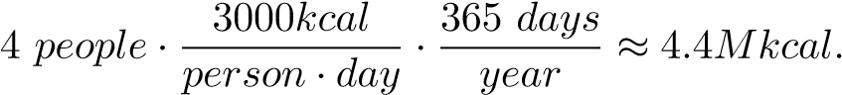

From figure **3** we can estimate 1*.*9 *million kcals* per acre of potato production.

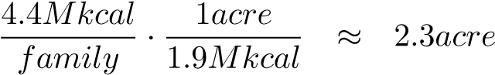

What does the answer of 2*.*3 acres mean? A university’s 91*m* × 49*m* football field has an area of about 1*.*1 acres, so you could say that a football field, planted in potatoes, will probably feed a family through the winter. [13] Can a person enjoy the benefits of urban living and grow all their own food? The population density of New Jersey is 1*,*263 *people/mile*2 ≈ 1*.*97 *people/acre* and our 4 person family needs 2*.*3 acres for their potatoes. Unless the social model is one of a country Dacha or an endless suburb with no duplexes or apartment buildings, urban living and food self-sufficiency seem mutually exclusive.

More emotionally charged conversations can be had about converting the United States to all organic agriculture, which, for corn, typically has a yield penalty of about 20 − 40*bu/acre* when compared to conventional production. The 1917 data isn’t directly applicable, but it relates. At 180*bu/acre* conventional corn requires ≈ 24 *million acres* (half of Wisconsin, or all of Indiana) to feed the US population (350 million people) corn for a year. The remainder of the corn belt can be devoted to animal feed, ethanol, and export. If the corn belt was devoted to producing organic corn at lower yield, [12] we probably wouldn’t starve, but cheap meat and ethanol vehicle fuel would likely disappear.

**Example: How big could Tenochtitlan have been?**

While a discussion of food energy is certainly useful in an introductory physics context, more powerful ethical arguments can be made. The first example relates to the pre-Colombian capital of the Aztec Empire, Tenochtitlan, now known as Mexico City. Tenochtitlan was built on and around an endorheic lake, Texcoco. Crops were grown in shallow parts of the lake via chinampas [3] floating patches of decaying vegetation and soil. Given the proximity to water and decaying vegetation, these fields were very fertile [9, 14] and some continue to be used in the present day.

footnote: Chinampas are still visible in satellite imagery. See for example latitude=19.268, longitude=-99.087.

Estimates of Tenochtitlan’s population in 1500CE vary widely, from 40,000 [15] to more than 400,000 inhabitants[5], comparable in size to Paris at that time. These estimates come from oral and written records and estimates of archaeological building density and land area. While cannibalism was part of Aztec religious ritual and practice, [28], the staple Calorie sources for the Aztecs were Corn, Beans, Quinoa, and Amaranth.

Few if any Native American cultures made use of draft animals for food or power before the Colombian Exchange. This means that the food that fed Tenochtitlan must have been brought to the city center by foot or canoe. How much land must have been devoted to chinampas to feed the population, or conversely, how many people could be supported by the land within walking or paddling distance from the city center?

Figure 4 imageJ_analysis.jpg Three screen captures showing chinampa areas near Tenochtitlan and the calibration stick used to convert pixel-squared area into miles^2. The image being analyzed is available online. (Coe, 1964)

A 1964 paper in Scientific American [9] gives a general outline of the chinampas near Tenochtitlan in 1500CE. This map, shown in figure **4,** seems to be the basis for the similar figure in Wikipedia. (<https://commons.wikimedia.org/wiki/File:Lake_Texcoco_c_1519.png>, 2016) Descriptions of chinampas agriculture indicate that as many as 7 successive crops could be grown and harvested from the same plot of soil each year, two of which could be maize (corn). This is truly amazing productivity, given that in the Midwestern United States, corn is normally grown, at most, every other year because of its extreme nutrient demands on the soil.

There are many ways to approach this estimation problem. We could assume a Tenochtitlan population of 100*,*000 people has a 3000*kcal/day* diet that comes completely from corn. If corn’s density and nutritional content haven’t changed in the 4 centuries preceding the 1917 data in figure **3**, we could assume 1*lbs* of corn contains ≈ 1594*kcal* of food energy. Looking at the map with ImageJ, [30] it seems like the recorded area devoted to chinampas might be about 16*,*000 *acres*. With these assumptions, we could equate the corn energy production from chinampas with the population’s yearly food need. Note, in this version of the story, the corn productivity, is treated as an unknown variable.

This crop productivity is in remarkable agreement with the 1917 USDA yields, 35*bu/acre*, which seems to validate the assumed 100*,*000 person population of Tenochtitlan, and certainly invalidates the claim that Aztec Cannibalism was necessary because of starvation (Bernard R. Ortiz De Montellano American Anthropologist , Jun., 1983, New Series, Vol. 85, No. 2 (Jun., 1983), pp. 403-406) . Some references [9] describe an extensive tribute system that Aztec government required of its subjects, which certainly would have been necessary to support populations on the upper end of historical estimates. [5]

**Example: Was the Irish Potato Famine a Natural Disaster?**

In contrast to native cultures of the Americas, Ireland’s population boomed with the Colombian Exchange and the introduction of the potato. [16, 29] Figure **5** shows that from about 1700 onward there was a dramatic growth in the island’s population. There’s never just one reason for historical events, but unlike grains, potatoes thrived in Ireland’s cool damp climate. Potatoes, kale, and milk form a nutritionally complete diet that greatly reduced hunger-related mortality among the poor working-class in Ireland. If you look closely at the data in figure **5** you might believe that there were at least *two* weather and potato related famines, the most obvious 1845-49 and the second, with much smaller effect on population in 1740-1. Both famines were precipitated by poor weather, but an important difference was that in 1740, Ireland was a sovereign state, but by 1845 the island was effectively an economic colony of the British Empire. [16]

Figure 5 Population-of-Ireland-since-1600.png The population of Ireland over time, file from Wikipedia. (File:Population of the island of Ireland since 1600.png, 2010) The humble potato, kale, and milk were part of an amazing population boom. Note that there were a number of weather-related “potato” famines in Ireland, the most obvious in about 1740 and 1850. Government policy response to the famines could explain the drastic difference in subsequent population following each of the two famines. The population of Ireland finally re-reached its 1851 peak in 2021. (Carroll, 2021)

As the story goes, the two main commodity crops in Ireland were potatoes (for humans), and oats, which as horse feed, were something like gasoline in today’s economy. A sovereign government can halt the export of food to feed English horses, which is what happened in 1741 (and 1782). The grain was diverted back as relief to starving people in Ireland, reducing the famine’s mortality. However, by 1845 most of Irish farmland was economically controlled by foreign (English) markets, and grain traders typically refused to divert oats (horse feed) as famine relief for the sake of their investment income.

This inflammatory claim, which is certainly a simplified version of history, serves as a useful evaluation example for students. Specifically, in years that the potato crop failed because of weather or late blight, could the amount of oats produced (and exported) have fed the Irish population? More broadly, was the Great Famine due to weather and disease, natural causes that “we can’t do anything about,” or was the depth of the tragedy a result of political choices?

Some estimates follow: Ireland’s population in 1845 was about 8*.*5 million people. The island has an area of about 84*,*400*km*2 and you might estimate that 64% of the land (54*,*000*km*2) is arable for agriculture.[1] It seems reasonable to use the 1917 productivity, figure **3**, to make calculations for Ireland in 1845. Reminder, in 1917, potatoes produced 1*.*908 × 106*kcal/acre* and oats 1*.*254 × 106*kcal/acre*. With students, evaluation of the claim could be approached as a series of questions:

How much food does the island need?

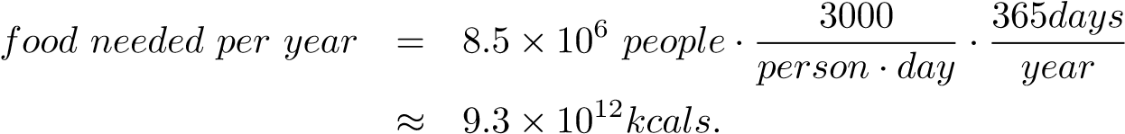

How much land area, sown in potatoes, would produce this food?

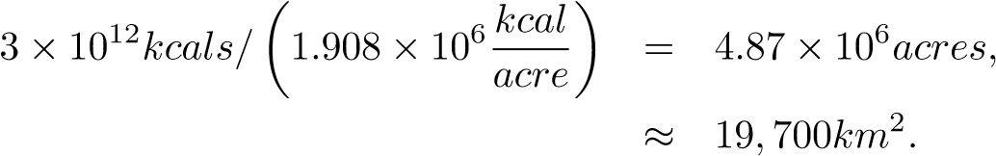

How much land area, sown in oats, would produce this food?

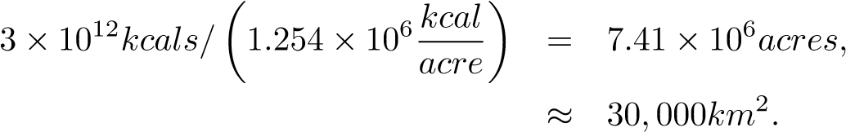

Summed, 49*,*700*km*2, these two areas devoted to oats and potatoes are roughly equivalent to the amount of arable land estimated above for Ireland, 54*,*000*km*2. [1] What do the numbers mean? Did there have to be a famine? If the entire potato crop failed because of late blight, there would likely have been enough oats to feed the population a 2000*kcal* ration with leftover oats to spare. Like the Holodomor or the Great Leap Forward, the numbers suggest that large-scale suffering wasn’t a natural disaster, but rather a human disaster resulting from malicious government policy insensitive to the value of human life.

**Conclusion**

A class about Energy and Social Policy and the author hasn’t mentioned climate change, coal, or solar panels even once! What is he thinking?

How many tons of carbon does your car release in a year? How many shiploads of iron oxide will we have to dump into the ocean for phytoplankton to eat up the equivalent amount of carbon? Every question in a class like this is, to at least some extent, informed by numerical calculation and it seems pretty arrogant to assume that “those students” don’t need to (or can’t) do the math. If you’re going to have success talking about numerical calculations, you might as well start with examples that everyone can relate to, and everyone eats! Along the way you might find fascinating historical questions to investigate.

The work was influenced and improved by discussions with Diane Dahle-Koch, John Deming, Carl Ferkinhoff, Larry Moore, and Sarah Taber.